Musculoskeletal system

Learning outcomes

- To understand movement
- To describe structure of bone and muscle
- To understand how muscle and bone communicate with the body

This is the system that provides support, structure and strength to our dogs, it’s also the system in which provides movement. Muscle activity burns oxygen and generates a lot of our body heat and can be energy demanding. Feeling strong and fit brings confidence and allows us to interact with our environment. The skeleton provides the frame for muscles to lever from, it protects our organs and provides minerals. In this module we will be looking at the structure of bones, joints alongside the function and structure of muscles. A knowledge of names and functions of important but I would strongly encourage you to put your hands on a dog during this module and see if you can identify the more obvious muscles and bones from gentle manipulation. Spending some time with a practitioner or veterinary nurse would be ideal to bring these muscle and bones to life.

Bone structure

Bone is a highly specialised connective tissue with a hard calcified matrix. There are four main types of bones

- Long bones – found in limbs
- Short bones – in the wrist
- Flat bones such as the scapula or shoulder blade
- Irregular bones such as the vertebra in the spinal column

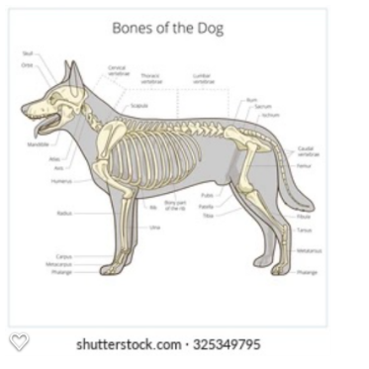

Figure 4 Skeleton

Bones have evolved into these four categories to optimise their function. As well as different shapes bones can be described by their structure. Compact bone is dense and solid in structure and cancellous bone which has a spongy structure

Long bones including the radius, ulna and femur. Long bones are covered in a dense fibrous layer called the periosteum. This sheet extends over the tendons where they join and interconnect. The periosteum support the living bone by carrying blood vessels and cells required to breakdown and rebuild bone.
Underneath the periosteum is the compact bone. These are formed by tightly packed cylindered systems called Haversian systems or osteons. These are made up of layers of calcified matrix called lamellae. The cylindrical shape gives extra strength to the bone . The Haversian systems have blood vessels, nerves and lymphatic vessels running through them.

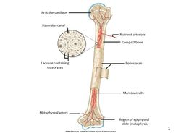

Figure 5 long bones

Although in a solid state bones are active and constantly renew. Bones are shaped my stresses and influenced by activity during growth.

Maintenance of blood calcium

98% of calcium is stored in the bones which play a huge role in maintaining the blood calcium level by homeostasis. Calcium on the blood is responsible for several jobs including blood clotting, nerve impulses and muscular contractions. Calcium is prioritised in the blood over the bone. The body regulates the level of blood calcium with the help of the parathyroid hormone. This hormone will stimulate the breakdown of bone cells so the calcium can be released into the blood stream

Long bones contain spongy bone underneath the compact bone and at each end (epiphysis) medullary cavity in the middle of long bones contains bone marrow. In younger mammals the marrow produces red and white blood cells, as the animal ages the marrow contains more fat.

The skeleton is far from dense static material it is very much alive and productive, spongy bone is constantly re arranging to accommodate stress and therefore protect the bones overall. Bone remodelling has been shown to be influenced by electromagnetic fields and is used to speed up fracture healing. Hormones have an influence on bone cell activity which has been researched in terms of early neutering, sex hormones effect growth plate closure when an immature animal becomes fully grown.

Cartilage

This specialised connective tissue has a consistency of a firm plastic or gristle like gel. Cartilage sits everywhere in the skeleton where articulation or movement takes place, namely joints. There are three types of cartilage,

- Fibro cartilage found in the spinal column
- Elastic cartilage – a stretchy cartilage found in the ear nose and epiglottis
- Hyaline cartilage – made of densely packed collagen fibres. Hyaline is tough and a shock absorber in the joints

Articulation

Articulation describes the movement of joints. There are 3 types of joints classified by the way the bones are connected within the joint

- Fibrous – held tightly together with little or no movement
- Cartilaginous- these have some degree of movement and are held together by hyaline and fibro cartilage
- Synovial joints – free moving and the most common type of joint. This joint is surround by a fluid filled capsule. Within the joint capsule you will find
- Capsule – an extension of the periosteum.
- Cavity – the space between the bones filled with synovial fluid
- Synovial membrane – slippery membrane that lines the capsule and secretes synovial fluid
- Articular cartilage – wraps around the articulating surface of the bone made up of hyaline cartilage.
- Menisci – supporting discs made of fibro cartilage, these often get damaged in knee injuries.
- Ligaments – strong fibrous that lock and hold the bones together.
- Bursae – fluid filled sac lined with synovial fluid provides a cushion between bones.

The Skeleton

Divided in two main sections, the axial and the appendicular. The axial consists of the skull and vertebrae. The appendicular comprises of the limbs.

The axial skeleton

The skull sits on top of the vertebral column. It is made up of many smaller bones fused together .The skull consists of two main parts the cranium which encloses the brain and the maxilla which forms the upper jaw. The skull has many holes that allow nerves and blood cells to pass through. The largest being the foramen magnum in which the spinal cord leaves the brain. On a skull you will be able to identify the eye socket or orbit, below which is the zygomatic arch in which the jaw muscles attach to. The skull has many sinuses which are air filled cavities.
The mandible is the lower jaw of the skull attached at the mandibular synthesis.

There are three distinctive shapes of dog skull

- Doliocephalic – long and thin example Borzoi
- Brachiocephalic – short and broad like a Bulldog
- Mesocephalic “ normal” skull

The dental formulae of the adult dog is

I3 C1 P4 M2
I3 C1 P4 M3

And
I3.C1 M3
I2.C1.M3 for puppies.

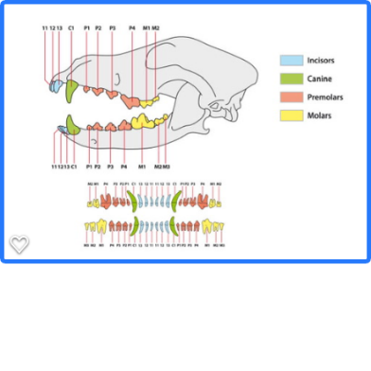
Figure 6 canine dentition
Teeth structure begins with hard enamel on the outside the next layer is dentine which surrounds the pulp cavity in which nerves and blood vessels sit. Teeth are very different in shape to reflect their different functions, the incisors being the least important sometimes used to tease soft tissue from bones, the long impressive canines catch and hold prey. Premolars and molars rip and shred and crush. The last upper premolar in the dog is known as the carnassial the largest three rooted molar.

The vertebral column consists of 7 cervical vertebrae, 12 thoracic, 7 lumber, 3 sacral and the coccygeal vertebrae in the tail. Each type of vertebrae are different in shape reflecting their different function.

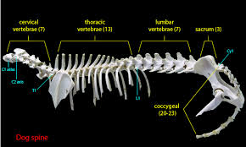

Figure 7 the vertebral column

The cervical vertebrae starts with a highly adapted vertebrae called the atlas with large wing like structures for muscle attachment. Moving on from the atlas to the second cervical vertebrae is the axis, you will notice the large hole running through these vertebrae for the spinal cord attachment.

Moving down from the neck we have the thoracic vertebrae which run along the thorax, these vertebrae have long spiny processes to attach muscle used for respiration.

Next are the lumber vertebrae much more bulky and rounded.

The lumber vertebrae run into the three sacral vertebrae, these are fused together provide less movement but structure and support for the pelvis.

After the pelvis we have rod shaped vertebrae that vary depending on the breed. The spinal cord ends after the first few vertebrae leaving just rods of bone to the tip of the tail.

Ribs and sternum

Running from the thoracic vertebrae are the ribs, dogs have 13 sets of ribs made of bone and cartilage, and Ribs from a joint with the vertebrae and join again at the sternum, the 13th rib is floating with a free end.

Appendicular skeleton

The forelimb is joined to the body my muscles only. forming the shoulder joint .

Scapula- Most cranially is the scapula a flat bone, triangular in shape. This sheet of bone at the caudal point it forms a joint with the humorous.
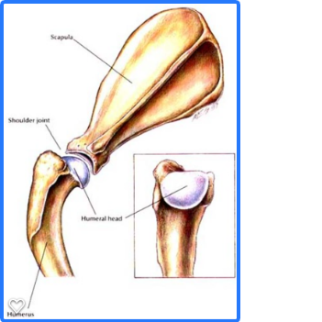Figure 9 the shoulder joint

Humorous is the long bone running from the shoulder to the elbow where it form a joint with two long bone down to the elbow.

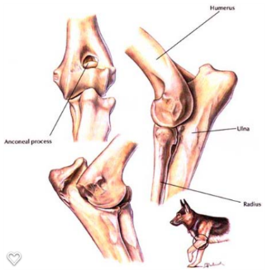Elbow joint

Radius and Ulna running from the elbow to the carpus or wrist are two bones are called the radius and ulna. Running side by side the ulna has the olecranon or point of the elbow.

The carpus is made up of two rows of very small bones joined by many ligaments. Running towards the claws from the wrist are the long rod like metacarpal bones. Dogs have four long bones leading to each toe. The fifth is the dew claw which originates at the carpus. The toes have three small bones called phalanges the most distal carrying the core of the nail.

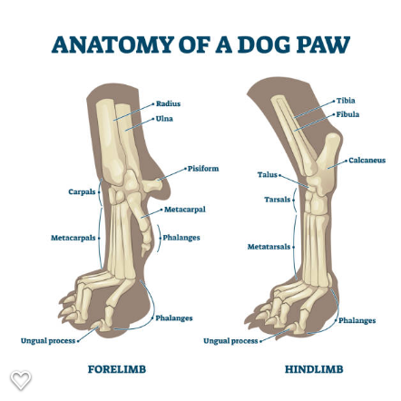

The hind limb

Originating at the pelvis a fused bone with much muscle attachment the femur forms the hip joint within the acetabulum.

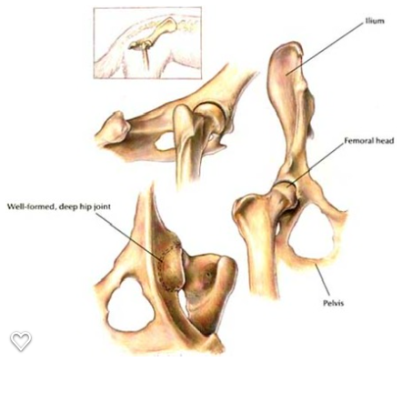
Figure 10 the pelvis

The femur has a large neck and head and is a long bone. The femur runs down to the stifle or knee where it forms a joint held together by cruciate ligaments. 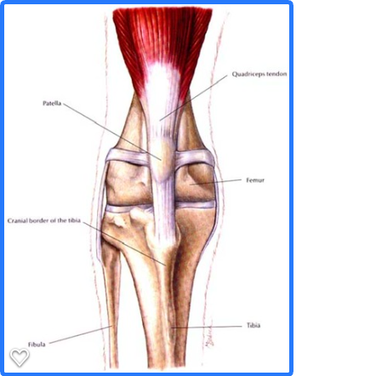

The tibia and fibula lie beside each other and run down to the tarsus or ankle. Like the carpus the tarsus is made up of small bones and forms the hock joint.

Four metatarsals run down to the toes from the hock, the dew claw is often absent on the hind limb.

The os penis. Male dogs have a bone in their penis called the os penis.

Dense bone need muscles to move, these two systems are easily associated together. We mustn’t forger the connection with the skeleton and other systems too. Bone helps regulate insulin as part of the endocrine system. Bone also communicates with the digestive system to regulate calcium uptake, the nervous system and cardiovascular system also have a communication and function for calcium. Oestrogen is involved in maintaining bone density and the kidney stimulates bone marrow production. From these example it’s clear to see that bone is much bone than a rigid structural support.

Muscles –

We are only beginning to understand the relationship with muscles and skeleton and the rest of the body. An understanding of fascia really helps aid movement and function for practitioners, and how it provides structure and movement. Connected to every organ in the body its web like structure send electrical impulse through the web when touched. Fascia is used by many therapists to relieve physical and emotional tension from trauma or stress. Meridian lines that are used in traditional oriental medicine called meridians seem to run through the fascia.

From bones our skeletal muscles connect and provide leverage. Muscles attach to the skeleton by tendons. Ligaments attach bone to bone such as the cruciate ligament in the knee or stifle.

There are three type of muscles tissue throughout the body

- Skeletal muscle is found attached to the bones of the body. This type of muscle is under voluntary control, meaning it’s a conscious control of the brain. Muscles attach to bone by tendons
- Smooth muscle throughout the body for example blood vessels and bladder lining this type of muscle contracts without a thought or instruction from the brain.
- Cardiac muscle – as suggested this is specialised heart muscle. Its short and cylindrical cells contraction is involuntary.

Muscle contraction

Muscle contraction is stimulated by nerve impulses. Muscle tissue is made up of two types of fibres myosin and actin. Thick Myosin and thinner actin overlap and move backwards and forwards to cause the contraction and relaxation of muscle. This process takes energy in the form of ATP.

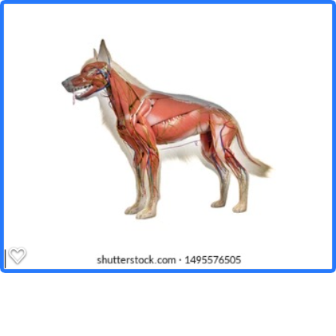

Muscles of the head

Muscles in the head attach to the skull and allow facial expression, feeding, and eye movement. The masseter and temporalis are the strong and aid jaw movement.

The forelimb - The trapezii muscle runs from the spine to the scapula to support and connect the forelimb, the skull is also connected to the forelimb by the brachiocephalic to bend the neck and protect the forelimb. The elbow is supported by the triceps and biceps running from the scapula to the ulna. The carpus or wrist has many small muscles that extend and flex the carpel joint.

The hind limb - The hip is a very versatile joint enabled to function by the gluteal muscles. Caudally between the hip and the stifle runs the ham strings which consist of the biceps femoris, semitendinosus and semimembranosus muscles. The quadriceps run cranially to extend the stifle. The hock movement is aided by the Achilles tendon where many other tendons run down into the metatarsals.

The vertebrae divided into two sections the epaxial muscles lie above the vertebral column and the hypaxial below. The hypaxial provide support for the column and the epaxial attach to the pelvis , sacrum, vertebrae and ribs to help movement.

The thorax, the intercostal muscles run from rib to rib and are important in respiration. The diaphragm is a sheet of muscle that separates the thoracic and abdominal cavity. Three holes in the diaphragm allow the oesophagus, nerves and blood vessels to run through.

Abdominal muscles – the four layers of abdominal muscles provide core strength and encase the abdominal organs. All of the muscles join along the ventral line at the linea alba or “white line” often visible on a dogs abdomen. The four muscles, internal and external oblique, transverses abdominus and rectus abdominus run in opposing directions to add to the strength of the abdominal wall.

Choose either the hind limb or forelimb and describe the bones and muscles involved in movement. Describe what effect that muscle has on the limb in terms of how it aids movement. 500 words

